Lab 9 - Continuous Integration with Jenkins

The Learning Objectives being covered require you to demonstrate you can work with a Continuous Integration tool.

The project supplied is written in Java, but Jenkins can be set up as a Continuous Integration pipeline for any buildable software.

# Objectives

1. To get Jenkins up and running on your system using Tomcat Server
2. To explore the options Jenkins gives us for connecting to other services
3. To explore the Jenkins dashboard

# Download the latest version of Tomcat 9

Download the version of Tomcat relevant for your operating system from this page:

https://tomcat.apache.org/download-90.cgi

(For Windows, choose the **64-bit Windows zip**, for other systems choose zip or tar.gz)

Expand the zip file and save in a folder like c:\ apache-tomcat-9.0.48

Expand the contents of the downloaded zip file into a suitable folder on disk (e.g. c:\tomcat)

# Download Jenkins Generic Java Package (.war)

Find the Long-term Support (LTS) version of the Jenkins Generic Java Package from this page and download it:

https://www.jenkins.io/download/

The file downloaded should be called **jenkins.war**

# Setting up the Tomcat Server

1. Open a terminal or Command Prompt
2. Navigate to the /bin folder in the extracted apache folder
3. For Windows...

* type the command startup.bat
* If a pop-up asks for permission to let Tomcat to go through firewalls, say yes

1. For MacOS:

* Change the ownership of the apache folder using the command  
  sudo chown -R <your_username> /<apache_folder_name>
* Change the permissions in the **bin** folder using the command  
  sudo chmod +x /<apache_folder_name>/bin/*.sh
* With the terminal pointing to the **bin** folder type the command startup.sh

1. Some logging should be done in the console.
2. Navigate to <http://localhost:8080> in your browser to check to see that the server is running.

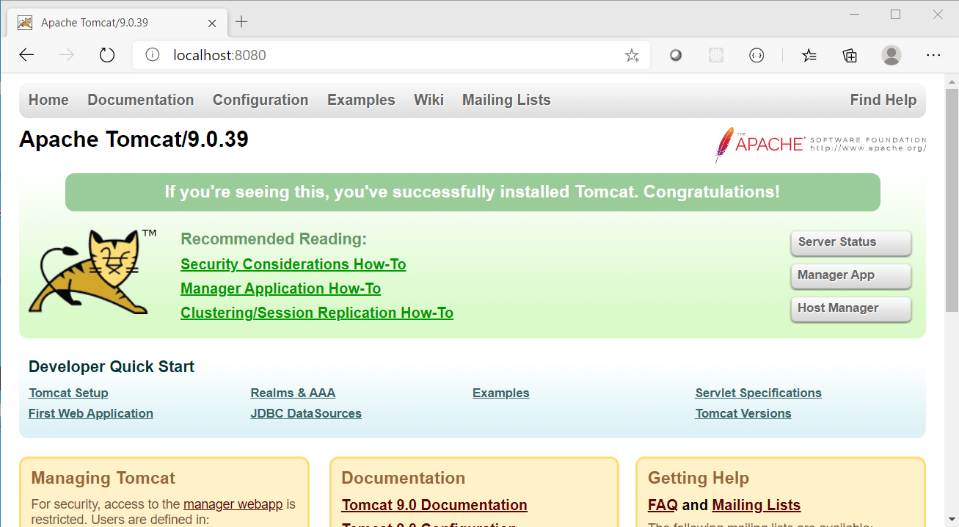

# Installing Jenkins

1. Copy the jenkins.war file you downloaded earlier into the <apache_folder_name>/webapps folder
2. A folder called Jenkins should be automatically generated
3. Navigate to <http://localhost:8080/jenkins>
4. You should see the Jenkins login page

# Initially Setting Up Jenkins

1. Jenkins (now) requires you to provide the admin password when first accessing the server. Follow the instructions on the screen to retrieve it.

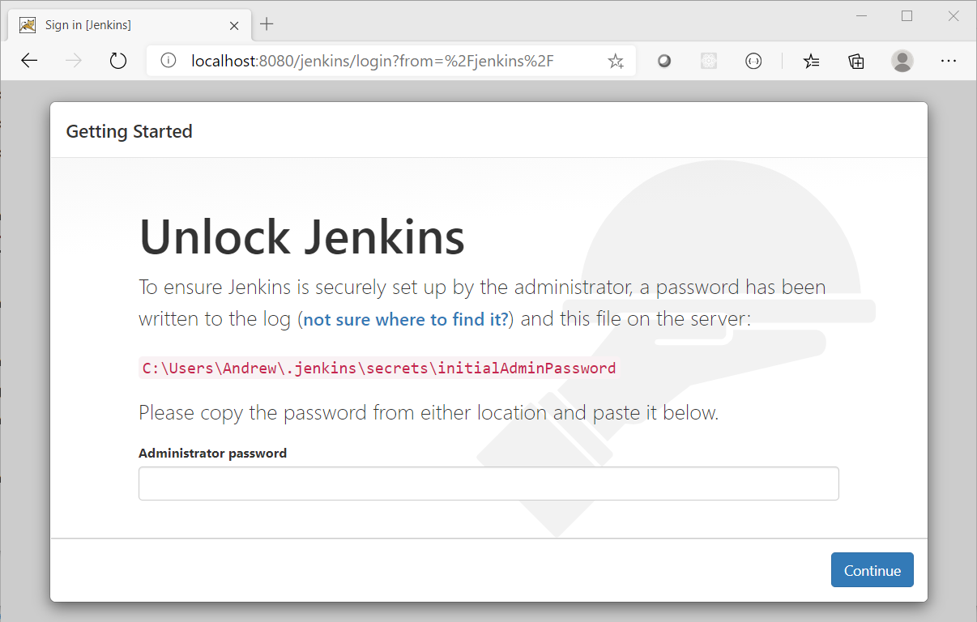

1. Obtain the initial admin password and copy it into the input in the window and click Continue

* For Windows, use the type command followed by the appropriate path (as shown on screen) for your system
* For MacOS, locate the file through Finder and open it with ‘Text Editor’

1. When the next screen shows, you will be prompted to decide which plugins to install initially

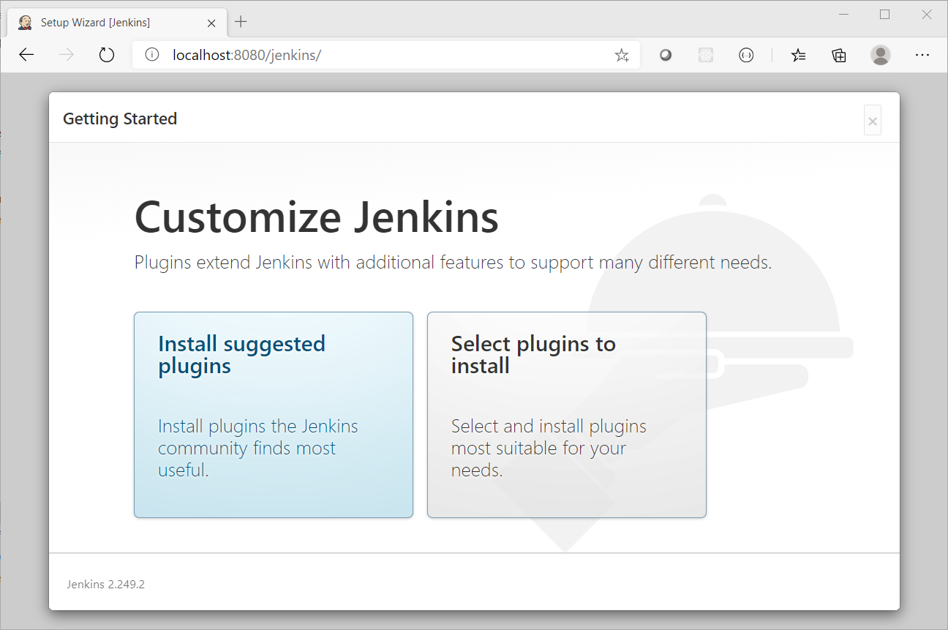

* Click Select plugins to install
* Do not remove any of the defaults
* Add the following by checking their box (you may find it useful to use the search box on the page to filter the list down to find each one)
  + JUnit - allows JUnit tests to be run
  + BitBucket - allows integration with a BitBucket repository
  + Matrix Project - a multi-project configuration tool
  + WMI Windows Agents - allows you to setup agents on Windows machines (not required on MacOS)

1. Click Install and wait for the process to complete

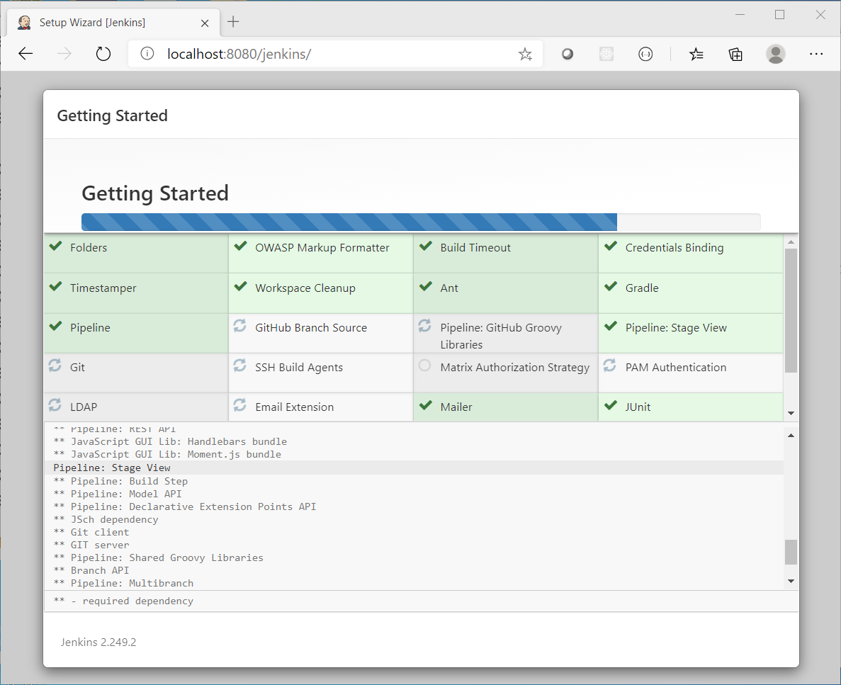

1. When the installation completes, create a user called root with a memorable password, click Save and Finish

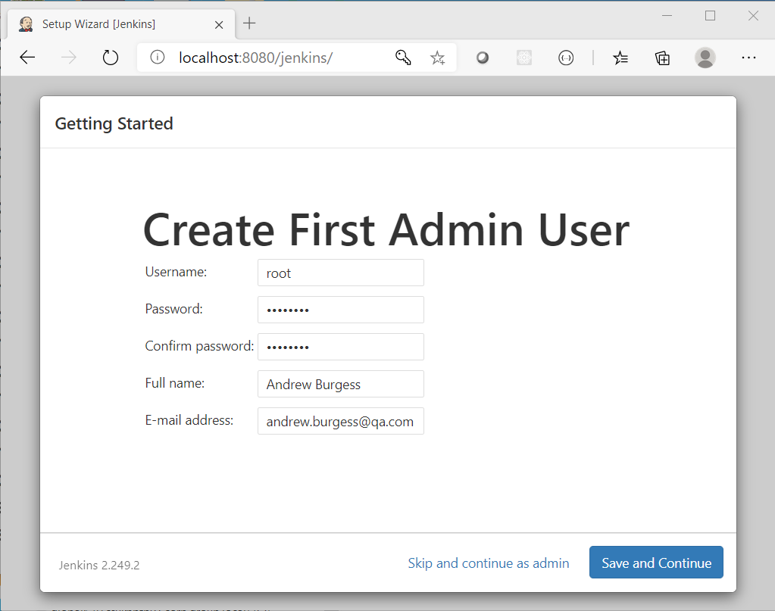

1. Leave the default URL and click Save and Finish again

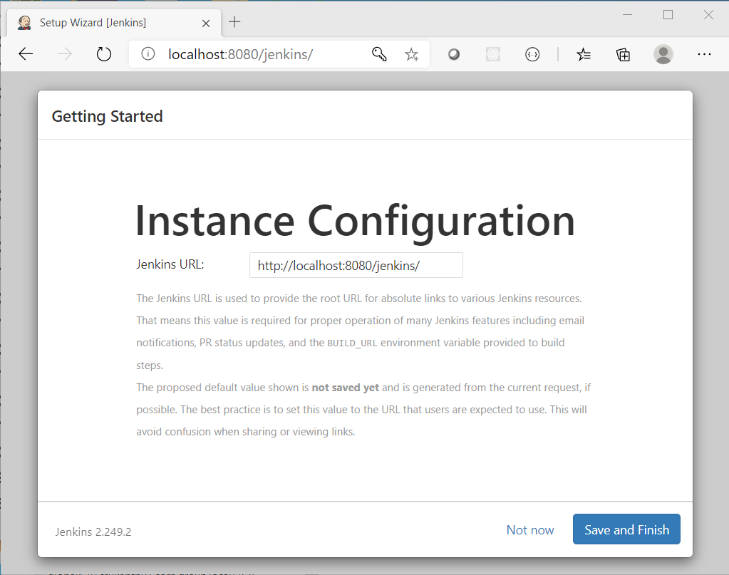

1. Click Start using Jenkins

If Jenkins looks like it is frozen when you click save and finish, refresh the page and continue as admin. The password will be the one you retrieved earlier from the file, but this can be changed via the dashboard later.

You should now be presented with the dashboard. If it looks like the installer has crashed, then refresh the page. If this keeps happening, click Continue as admin rather than add a new admin user.

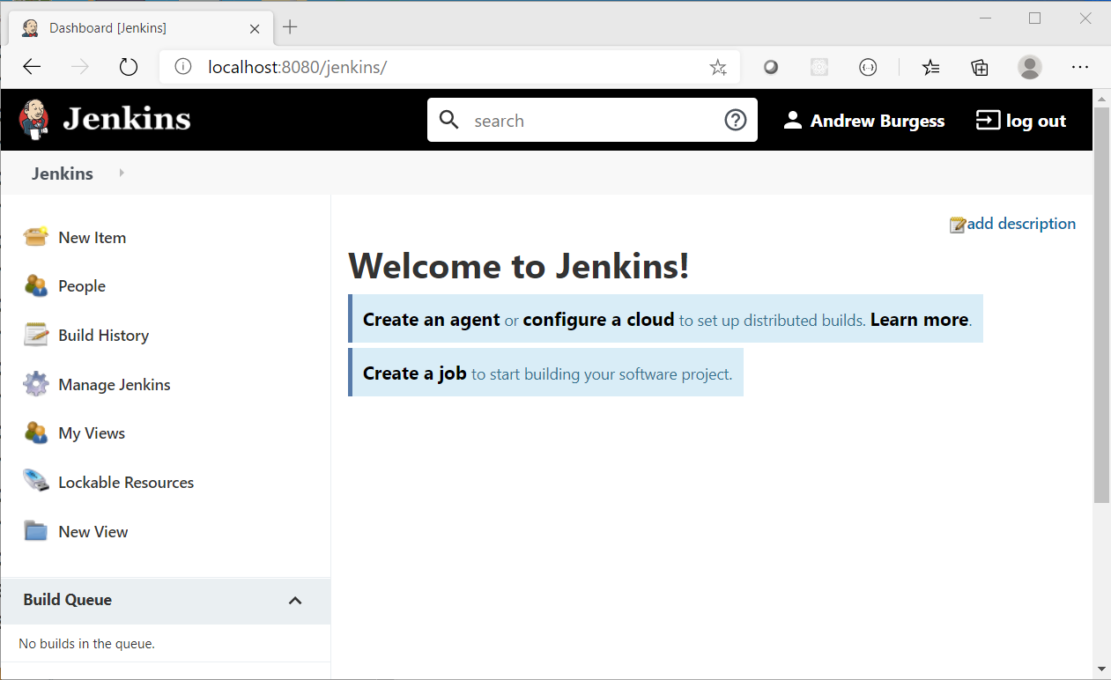

# Installing Build Plugins

1. Click Manage Jenkins from the menu on the left of the screen
2. Find Manage Plugins from the list in the middle of the screen and click on it

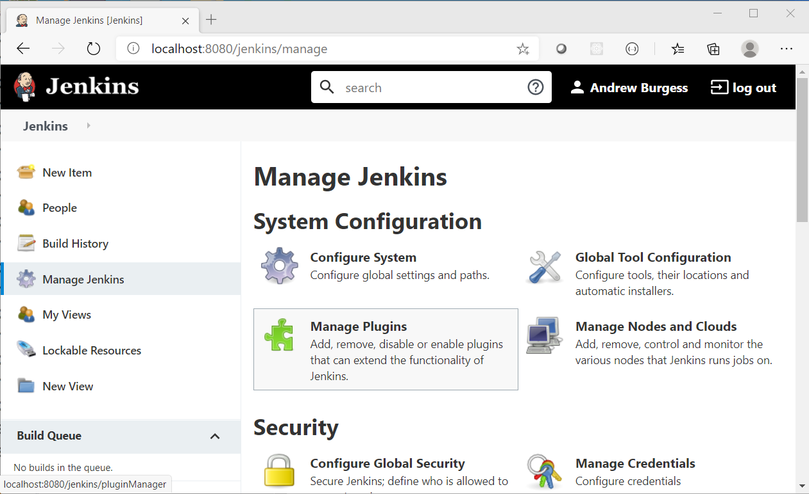

1. Click on the Available tab ad then search for Maven Integration

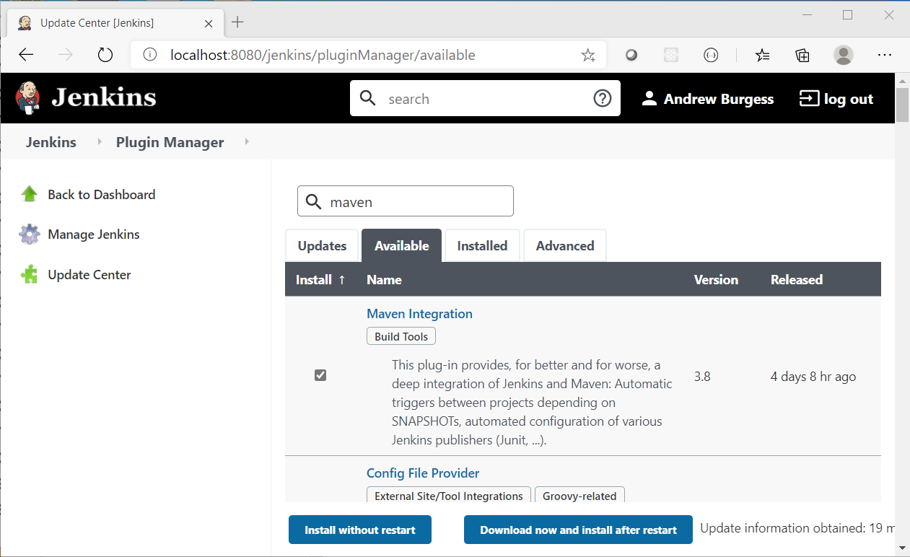

1. Tick the Maven Integration box
2. Click Download now and install after restart
3. Go back to your command / terminal window and stop Tomcat (ctrl-C)
4. Restart Tomcat, the same way you started it before
5. Refresh your browser, and log in again to Jenkins, using your root user credentials

# Enabling Maven

1. Click Manage Jenkins from the menu on the left of the screen
2. Find Global Tool Configuration from the list in the middle of the screen and click on it again.

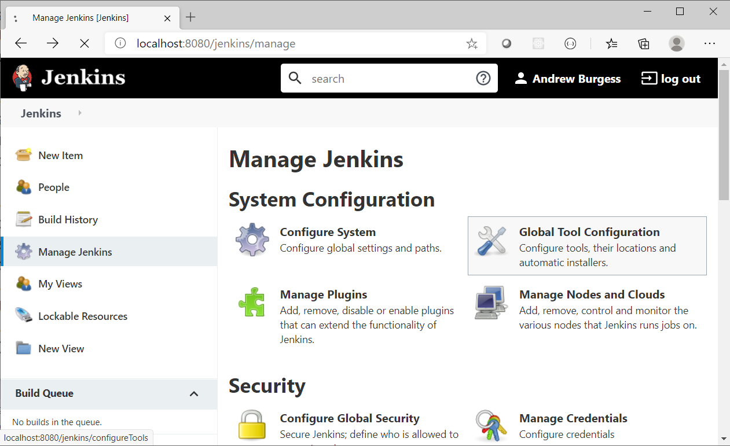

1. Scroll down until you find the Maven section and click Add Maven

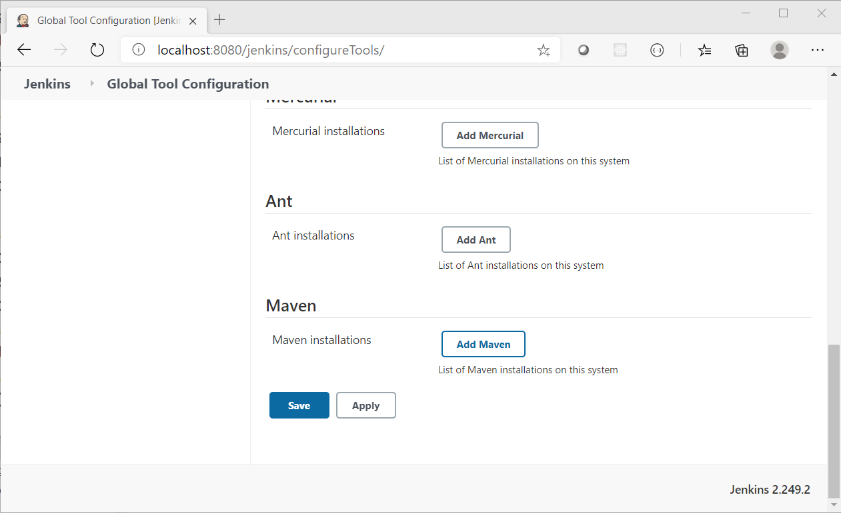

1. In the Name input box type M3 and click Save

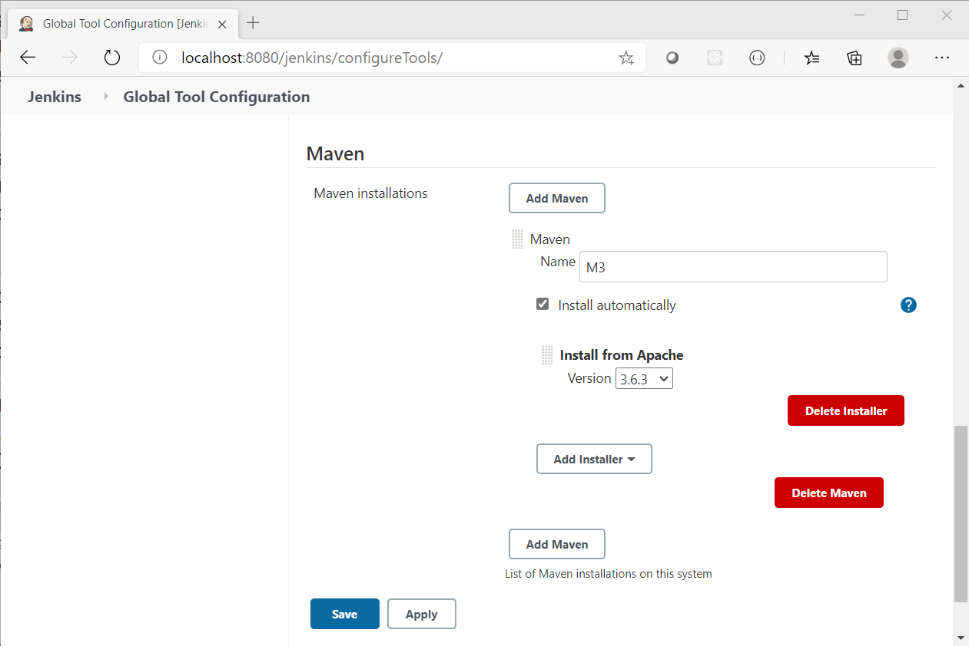

1. You will be returned to the Manage Jenkins screen - it is now configured to build Maven jobs!

# Creating a Job

In this part of the activity, you will get Jenkins to monitor a pre-built project and build it and rebuild it on changes. This will be done via local files, but it can be configured to monitor Git repositories and rebuild when there are new commits to them.

# Initialise the Calculator as a Git repo

For this part of the activity we need to set up a new local Git repository. The initial content of the repository will come from this lab's starter files (Lab 9 - Java starter).

1. Copy the calculator-jenkins folder to another place on disk (e.g. c:\calculator-jenkins)
2. Open a terminal / command window, and navigate into the folder above, e.g.

cd c:\calculator-jenkins

1. Initialise the folder as a new Git repo:

git init

1. Add all of the files:

git add .

1. Commit the files:

git commit -m "Initial commit"

# Set up a Job

1. Reopen your browser window and get to the Jenkins dashboard <http://localhost:8080/jenkins>, logging in if necessary
2. On the menu on the left, select New Item
3. In the Enter an item name input box type Calculator Job
4. Click on Maven Project so that a highlight box surrounds it

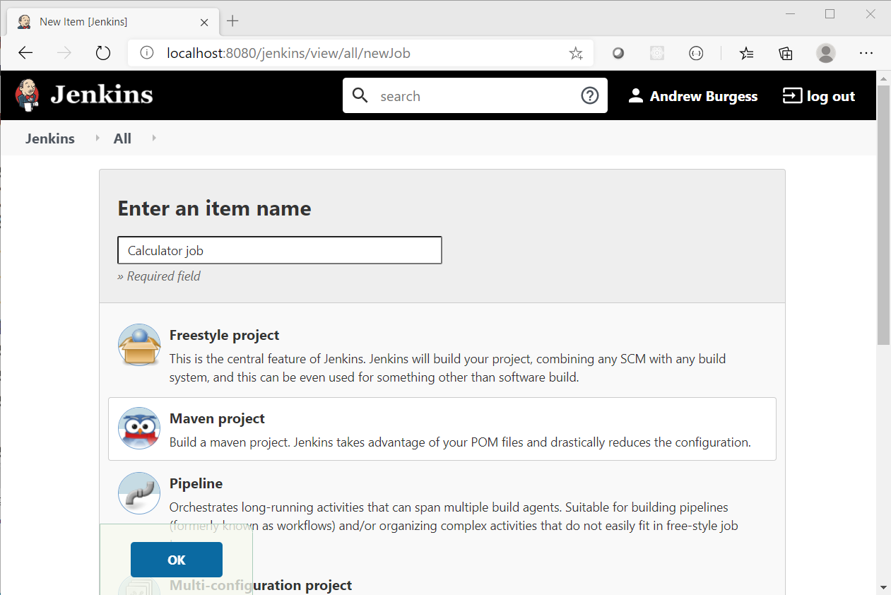

1. Click OK
2. On the next screen, scroll down to the Source Code Management section
3. Select the Git radio button and enter the path to your **Calculator-jenkins** project

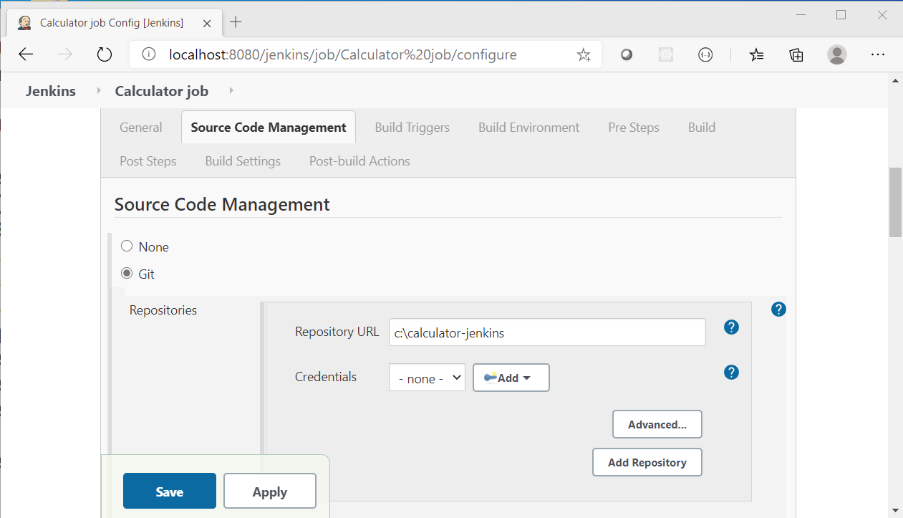

1. Click the Save button

# Build the Job

1. Click Build Now on the menu on the left of the screen - you will notice a stripy progress bar appears in the Build History section

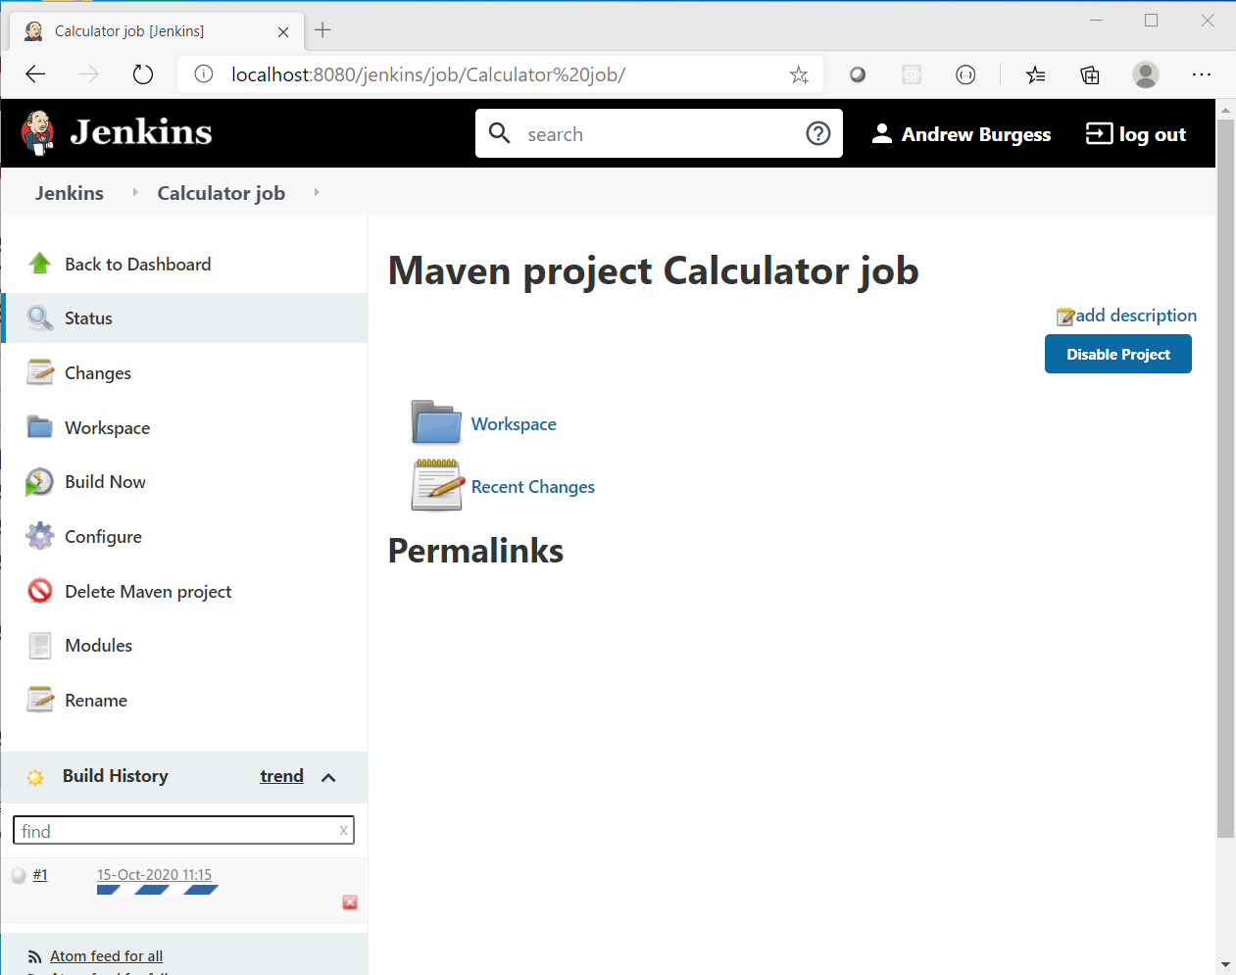

1. Once the Job is complete, the progress bar will be replaced by a number link - this is the Build Number

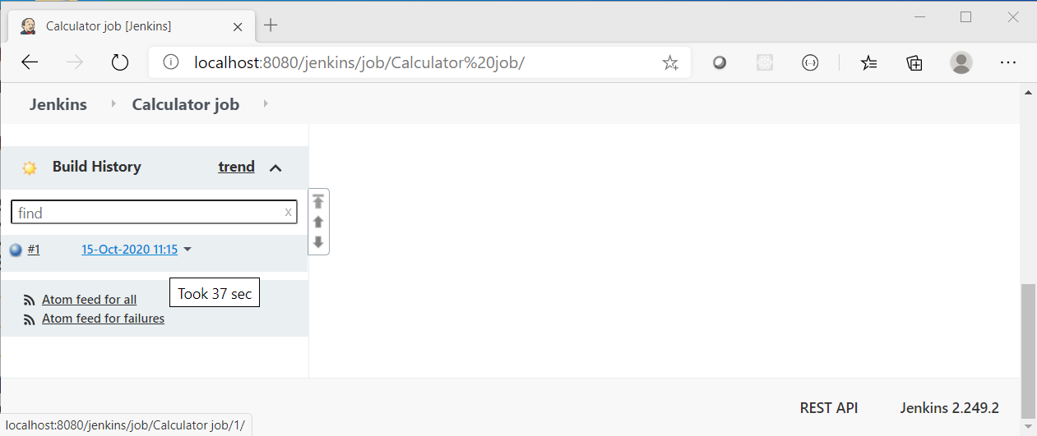

1. Click the link to view the Build results

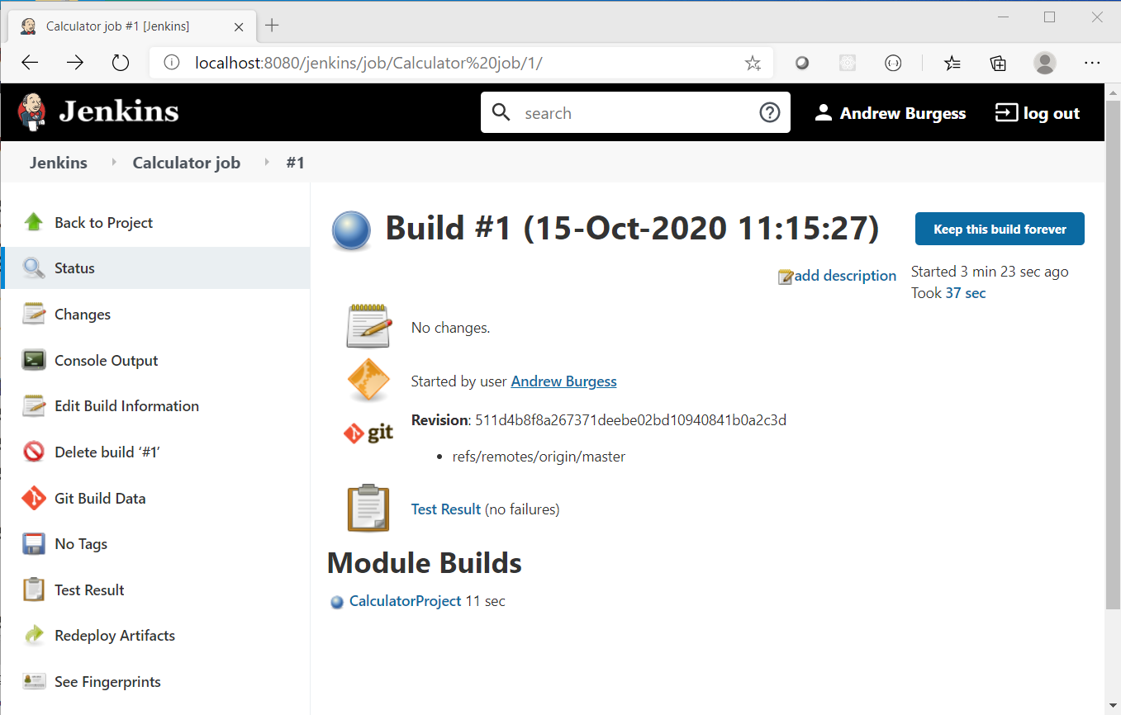

1. You will observe that all the tests have passed and that the build was successful.
2. Explore the information on this page and the linked pages, for example try drilling down into the test results, or the build artifacts.

# Configure Jenkins’ Build Triggers

1. In the **Calculator Project** window, select Configure from the left-hand menu
2. Click on the Build Triggers tab
3. Check the Poll SCM (Source Control Management) box
4. Enter * * * * * into the Schedule input box (Note the spaces between each *)

* **Schedule** value uses the *chrontab* format - * * * * * tells **Jenkins** to poll the Git repo every minute
  + Using H * * * * would change the schedule to every hour - for some examples see [Chrontab Guru](https://crontab.guru/examples.html)

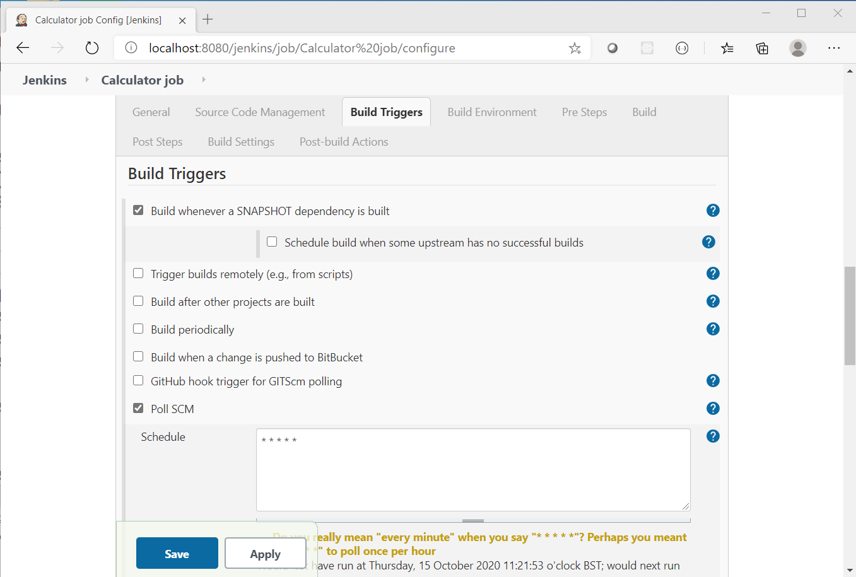

1. Click the Save button

Jenkins will retest and rebuild the project every time a commit is made to this repo.

# Making Commits

If you are used to Java, open the project in an IDE, make some changes, commit them and then skip to the next section. (You'll probably need to "import" the project into your workspace, first).

We suggest making **at least 1 test fail** to have a visible effect on the build.

If not, follow these instructions:

1. Open the file CalculatorTest.java from the project path /src/test/java/com/agile/calculator
2. Change the value of expected on line 17 to 42
3. Save the file
4. Add and commit this file to the repo

# Monitoring the Build

You should notice that within a minute (our scheduled poll time), a new build should initiate and complete. (Do not be tempted to click Build Now as changes in the repo may not be collected).

The change(s) to the repo will be picked up and the project will be built, running the tests. This build will appear as UNSTABLE and if you investigate, you should be able to find out the reason why.

In our case, we followed the instructions above and clicking on the build shows that indeed the subtractTest failed.

Clicking on the link reveals the console output and at the top you can see that we got a result of 2 instead of the expected 42.

# If you have time - further exploration

Revert the test to its passing state and verify that the build is successful again.

Try modifying the Calculator.java file - perhaps add a comment and/or change a return of one of the methods so the test will fail.

Let **Jenkins** initiate a build and verify the results are as you expected.

# Round Up

You have seen that **Jenkins** can monitor a **Git** repository and, of course, you can hook it into remote repositories - using WebHooks. It can also be configured to run *linting* tools and package and deploy your code.

This sort of tool is an essential part of the Continuous Integration (and Delivery and Deployment) pipeline.